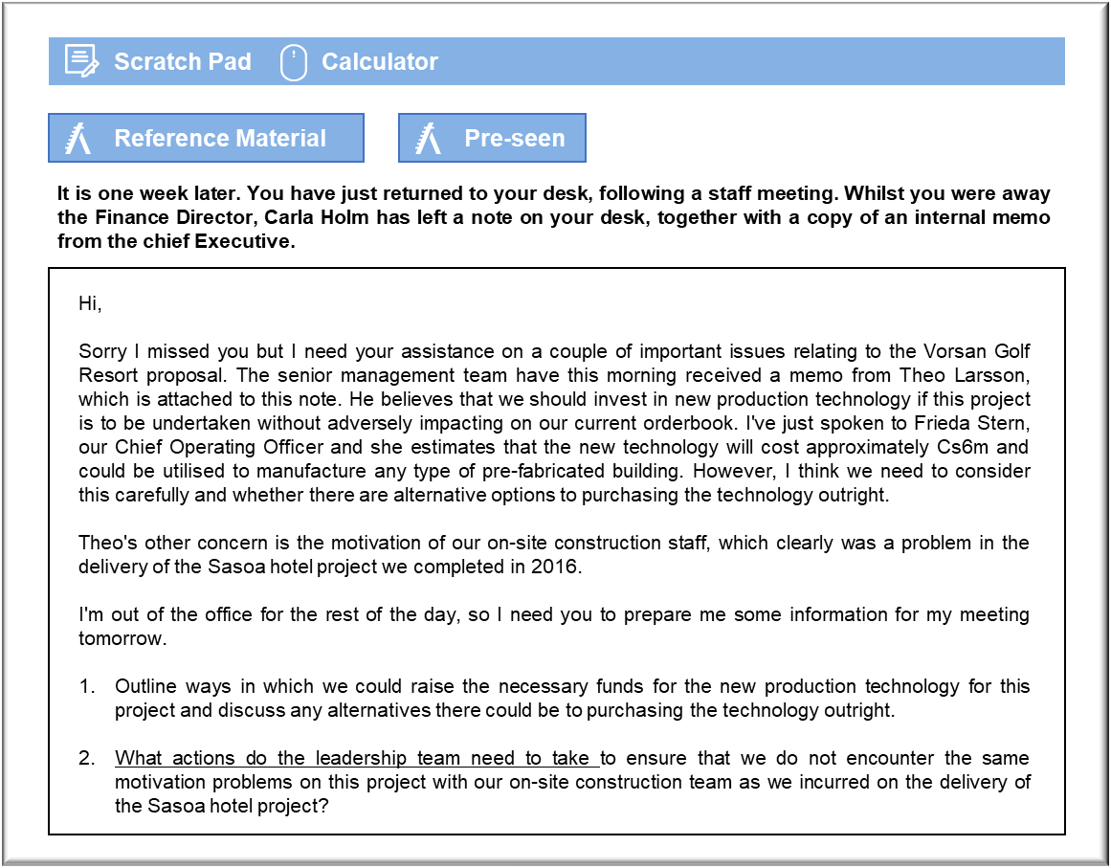
- Bluebook Page33 May 2019 Variant Two examination:

MANAGEMENT CASE STUDY MAY 2019 EXAM ANSWERS

Variant2 Task2
These answers have been provided by CIMA for information purposes only. The answers created are indicative of a response that could be given by a good candidate. They are not to be considered exhaustive, and other appropriate relevant responses would receive credit.

CIMA will not accept challenges to these answers on the basis of academic judgement.

Alternatives for funding the proposed new production technology
Fresh equity would be a consideration, but that might be difficult to arrange because,
collectively, the members of the Larsson family control 60% of the company and so
they may be nervous about diluting their control. There are only nine shareholders, in
any case, and they may be reluctant to upset the company’s stability by introducing
new shareholders, who may wish to push the company in a different direction.
A rights issue would give existing shareholders the right to subscribe to new shares in
proportion to their current shareholding. That would deal with concerns about
dilution, but Jord is unlisted and it seems unlikely that the shareholders will be able to
invest a further C$6 million between them. The Larsson family members would have
to find C$3.6 million.
Debt may be a sensible option given Jord’s financial history. There is no debt currently
held by Jord and given its historic profitability there would be ample opportunity to
borrow from a bank. This would also give the benefit of a ‘tax shield’ as our interest
payments will be tax deductible. You should note however that this borrowing will cost
interest charges and will need to be repaid out of operating cash flows over the next
few years.
Alternatively, we could use our cash balance to fund this project, although this may
require sacrificing dividends payable. In 2018 there is a cash balance of C$26 million
but dividends payable are C$17 million and these are due to be paid in July which will
reduce the cash balance significantly. These dividends are still, however, unpaid and
could be used to fund the project effectively achieving the same result as a fully
subscribed rights issue.
One possibility would be to lease the new technology. It would be possible to have a
bank or leasing company acquire the new technology, as specified by us. They would
then grant us the use of the assets for the term of the lease. Technically, the lessor
would retain ownership of the leased assets and so there should be no need to lodge
separate collateral in support of the lease liability. The lessor will be able to repossess
the assets if we do not keep up with payments.
Leasing would have virtually the same implications as taking out debt. The lessor
would be unlikely to buy specialised assets to our specification unless we committed
ourselves to a lease term that made economic and commercial sense to both sides. It is
unlikely that we could simply return the assets in the event that they became surplus to
our requirements. We would probably have to maintain the lease payments even if
Phase II of the project does not take place.
There would be no real advantage to leasing in terms of financial reporting. IFRS 16
Leases would require us to capitalise the present value of the lease payments and the
assets themselves, based on the present value of the lease payments at the time the
lease commences.

May 2019 5 CIMA Gateway Case Study Exam

Leadership team actions to motivate on-site construction staff
It is clear that there were some motivational problems for the on-site construction
team when we delivered the Saspa project. High levels of sickness, absenteeism and
more worryingly, accidents, are strong indicators of poor morale, which is also likely to
have impacted on the quality of the final delivery of the project.
We need to ensure that we strive to achieve and encourage high performing teams that
have a clear purpose and objectives and a commitment to that purpose. One of the
issues we may have encountered in the Saspa project, is the lack of clear purpose, due
to this being a completely new type of construction for the on-site construction team.
This may not have been caused by the overall lack of understanding of the needs of
these team members by the leadership team.
Therefore, there are a number of possible actions that could be taken by the leadership
team to improve motivation of the on-site construction team. Firstly, Jord’s leadership
team must communicate the goals and objectives of the project clearly to the team,
prior to commencement. The construction team need to understand the importance of
their role in the successful delivery of the project. Team building exercises may need to
be carried out to develop a strong sense of team cohesion.
Jord’s leaders must also develop a clear form of communication between the team so
that any issues can be resolved quickly and efficiently. Communication, such as
developing and encouraging problem solving exercises should be developed to build
trust in the team and encourage team commitment. The leaders’ visibility, availability
and preparedness to discuss project related issues will have a significant positive
impact on staff morale.
Sufficient training in health and safety may also need to be given to motivate staff in
terms of their own personal safety whilst working overseas. Jord may also need to
consider team rotation. Clearly, the length of time away from home was an issue with
motivation previously and therefore a clearly defined plan should be set up whereby
teams know in advance where and for how long they will be away. This should be
communicated well in advance. We may need to consider incentivisation through some
form of financial reward, such as bonus payments. Although financial rewards alone
will not be motivating, they are means by which team members can feel more valued
and committed to the project
We may want to consider social events and interactions between the individuals in the
team to help to reduce any potential conflict and increase the cohesion of the group. In
addition to formal teambuilding exercises, managers can attempt to reinforce the
individual identity of the on-site construction team, strengthening team members’
sense of belonging and improving the efficiency of the group. This can be accomplished
by giving the team its own name or its own uniform.

